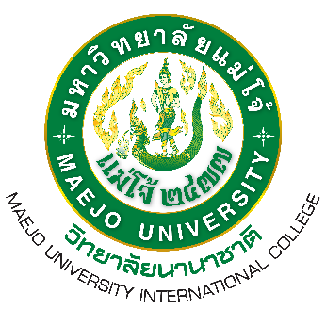
Assessment Report on Program Level according to
AUN-QA quality criteria Academic Year 2024
Master of Arts Program in Tourism Management (International Program)
International College Maejo University

Part I | Introduction
 | 1.1 | Executive Summary
 | 1.2 | How to Prepare This Self-Assessment Report
 | 1.3 | Basic Information
 |  | 1.3.1 | An Overview of the University
 |  | 1.3.2 | An Overview of the Faculty
 |  | 1.3.3 | An Overview of the Program
Part II | Self-Assessment
 | Indicators 1.1 |  |  |   Supervision of program standards according to the program standards set by the OHEC
 | Criterion 1 |  |  | Expected Learning Outcome
 | Criterion 2 |  |  | Programme Structure and Content
 | Criterion 3 |  |  | Teaching and Learning Approach
 | Criterion 4 |  |  | Student Assessment
 | Criterion 5 |  |  | Academic Staff
 | Criterion 6 |  |  | Student Support Services
 | Criterion 7 |  |  | Facilities and Infrastructure
 | Criterion 8 |  |  | Output and Outcomes
Part III | Strengths Analysis and Course Limitations
 | 3.1 | Strengths Analysis and Course Limitations
 | 3.2 | Curriculum development plan
 | 3.3 | Assessment Criteria
Part IV | Appendixes
List of Reference Documents (Additional Documents)
Common Data Set of the Program
Assessment Report on Program Level according to AUN-QA quality criteria Academic Year 2024 Master of Arts Program in Tourism Management (International Program)

